

INFLUENZA A H3N2

MULTIPLEX RT-qPCR TEST HANDBOOK
For Research Use Only. Not intended for diagnostic use.

CAT NO.: YS-qPX- IC-H3N2-100
100 reactions
With Internal Control and Frozen MasterMix

VERSION 1.0


YouSeq Ltd
8 Moorside Place
Moorside Road
Winchester
SO23 7FX
United Kingdom

+44 (0) 333 577 6697
hello@youseq.com

youseq.com

INTENDED USE

This RT-qPCR test offers an efficient and user-friendly solution for the detection of Influenza A H3N2 (H3N2) in extracted nucleic acid samples from a variety of sources. It is intended for use by trained professionals in a suitable molecular biology laboratory.

SPECIFICITY AND SENSITIVITY

Specificity

The YouSeq RT-qPCR test for detection of Influenza A H3N2 is designed to have the broadest detection profile possible and detect all clinically relevant strains. The primers and probes typically have a ≥95% homology with all reference data used, from relevant, publicly available databases at the time of design.

The target genes outlined below, have been demonstrated to have distinctive sequences making them ideal targets for highly specific detection.
Influenza A H3: HA gene
Influenza A N2: NA gene

For further information on the detection profile of the product, please do not hesitate to contact our team: support@youseq.com

Sensitivity

The RT-qPCR test is suitable for the detection of these targets across a wide dynamic range. Under ideal PCR conditions the assay can detect less than 100 copies of the targets in the PCR reaction.

CONTENTS

Component | Cap Colour | Volume
Multiplex primer/probe mix:  H3 (FAM)  N2 (ROX)  Internal Control (CY5) |  | 100 μL
TetraTM OneStep 2X RT-qPCR MasterMix |  | 1 mL
H3N2 Positive Control (PTC) |  | 500 μL *
Internal Control RNA Template |  | 500 μL *
Template Resuspension Buffer (TRB) |  | 1.5 mL
DNase/RNase Free Water |  | 1.5 mL
* Supplied dried – requires resuspension. See instructions in resuspension section.

RECOMMENDED ADDITIONAL REAGENTS & MATERIALS
Nucleic acid extraction kit – Internal Control RNA is to be included in the sample extraction. See ‘Use of Internal Control RNA’ section below.

General laboratory equipment (pipettes, pipette tips, (micro)centrifuge tubes, compatible strip tubes/plates, plate seals, etc.)

qPCR instrument with channels to detect FAM, CY5 and ROX.

BEST PRACTICE
Decontamination:
Before beginning laboratory work, thoroughly decontaminate any work surfaces and pipettes being used, to eliminate potential contamination.
General use and set-up:
All components should be fully defrosted with contents at the bottom of the tube before opening. To ensure contents are at the bottom, centrifuge or gently tap the tube. After use, reagents should be returned to the freezer.
Once any reagents are resuspended, mark the tick box on the tube for future reference. After this, or after combining reagents, the tube should be pulse vortexed to ensure it is mixed well.
It is advised to set up the tubes/plate and reaction mix on ice to minimise artefact formation, which may reduce sensitivity.
When preparing the qPCR reaction mix, it is recommended to incorporate an overage when calculating the total number of reactions to compensate for potential volume losses incurred during pipetting.
Set-up environments:
It is best practice to set up qPCR tubes/plates in two different environments - a clean (no template) lab and PCR (template) lab.
No Template Control(s) (NTC) and Positive Control(s) (PTC) should be included in every run. To reduce contamination, NTCs and samples can be set up and sealed in a clean lab before moving to the PCR lab.

BENCH SIDE PROTOCOL

RESUSPENSION

Before first use, resuspend the designated component with the correct reagent and specified volume, as per the table below:
- Add the resuspension reagent and pulse vortex the tube to ensure each is mixed well.

Component | Reagent | Volume | Location
Internal Control RNA Template | TRB | 500 μL | Extraction lab
H3N2 Positive Control (PTC) | TRB | 500 μL | PCR lab

USE OF INTERNAL CONTROL RNA

- At the relevant step of the extraction protocol, pause and add 5 μL of the Internal Control RNA into the extraction/lysis buffer for each sample that is to be extracted.

Please note: Do not add this Internal Control RNA directly into the biological sample as this may cause degradation of the control RNA.

- Continue nucleic acid extraction as per the manufacturer’s instructions.

RT-qPCR REACTION SET-UP

- Retrieve the required components and appropriate plasticware for RT-qPCR reaction set-up.
- In an appropriately sized (micro)centrifuge tube, combine the following reagents to create a reaction mix that will cover all required wells (e.g. sample(s), NTCs and PTCs).
Please note: When calculating required reactions, include an overage to allow for volume loss during pipetting

- Component | Volume per reaction
TetraTM OneStep 2X RT-qPCR MasterMix | 10 μL
H3N2 specific primer/probe mix | 1 μL
Reaction mix volume | 11 μL

Please note: It is recommended to work quickly with these components, on ice. The activity of Reverse Transcriptase enzymes at room temperature can create artefacts, which may impact assay sensitivity. YouSeq recommends the tube/plate set-up is no longer than 30 minutes.

- Mix the combined reagents by briefly vortexing or inverting.
- Dispense 11 μL of the reaction mix into all required tubes/wells.
- For the NTC(s), add 9 μL of DNase/RNase Free Water into required tube/well(s).
- For each extracted sample, add 9 μL into required tube/well(s).
Please note: It is best practice to seal the NTC(s) and sample tube/wells before proceeding to the positive control step.
- For the positive control(s), add 9 μL of the resuspended PTC, into the required tube/well(s).
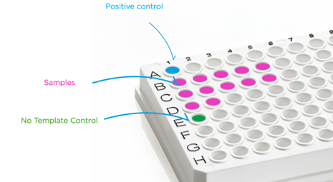
- Seal the tube(s)/plate.
- Briefly vortex the sealed tube(s)/plate, then spin in a centrifuge to ensure all reagents are fully resuspended and at the bottom of the tube(s)/wells before proceeding.

RT-qPCR AMPLIFICATION PROTOCOL
- Load the tubes/plate onto the qPCR instrument and set up the RT-qPCR protocol following the table below.
- Set the total reaction volume to 20 μL.
Please note: If using a qPCR instrument that uses ROX as a passive reference, ensure the passive reference is turned off or set to “none” before starting the run.

Temperature | Time | Number of Cycles
55°C | 10 minutes | -
95°C | 3 minutes | -
95°C | 15 seconds | x 45
  60°C | 60 seconds | x 45
Collect fluorogenic data through FAM, CY5 and ROX channels during this step.

- Start the run.

INTERPRETATION OF RESULTS - OVERVIEW
If using single threshold analysis – YouSeq recommends setting the threshold at 10% of the End Point Fluorescence (EPF) for each channel.
- For the Target channel, use the PTC EPF to set the threshold.
- For the Internal Control, use the average EPF from samples to set the threshold.

Results interpretation:

Reaction Type |  | qPCR Signal (Cq)
Positive control |  | 18 ± 2 | 18 ± 2 | 18 ± 2 | 18 ± 2
No template control |  | - | - | - | -
 | Internal Control: (CY5) | ≤ 31 | ≤ 31 | ≤ 31 | ≤ 31
 | H3 (FAM) | + | + | - | -
 | N2 (ROX) | + | - | + | -
Result |  | Positive result: Influenza A H3N2 | Positive result: Inzunza A H3 | Positive result: Influenza A N2 | Negative result

INTERPRETATION OF RESULTS – CONTROLS EXPLAINED
Positive control
The PTC should amplify in a Cq range of 18 ± 2 for each target. If this Cq range is not achieved, the sample test result for the associated target is invalid and should be repeated.
Please note: The positive control is a sequence representative of the target regions and does not contain the organism’s entire genome. The positive control does not include the Internal Control sequence and should not be expected to amplify in the CY5 channel.
No template control
The NTC well(s) should be negative, with no amplification.
Please note: Background laboratory contamination can result in a very late signal in NTC wells. If the NTC has amplification, comparison to the sample test result is necessary:
- If the NTC is ≥5 Cq later than the sample signal, it can be considered negative, and the sample test result is valid.
- If the NTC is <5 Cq later, the sample test result is invalid – the test should be repeated after potential sources of contamination have been removed.
Internal control

Detection of the Internal Control is through the CY5 channel. This gives information about the efficiency of the nucleic acid extraction. Cq values ≤ 31 indicate a successful extraction has taken place. If the signal is later than this, repeating the nucleic acid extraction is advised.

Please note: If the sample delivers a strong positive result for the target of interest, then amplification of the Internal Control may be affected and may appear later. In this case, lack of Internal Control amplification is acceptable, and the sample test result is valid.

Multiplex troubleshooting

 | 1 | 2 | 3
Trace | 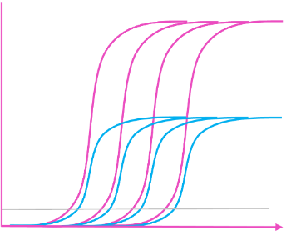 | 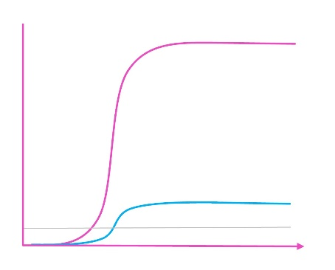 | 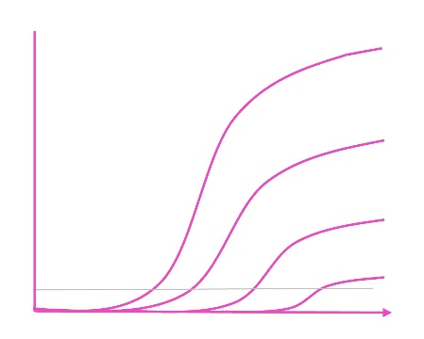
What can you see? | Different fluorescence levels between Targets | Unexpected low level of fluorescence, similar to amplification from a different channel, within the same well | Amplification for late positives have lower fluorescence, or appear “flatter” than the positive control
Cause | Fluorescence depends on the assay design and the channel e.g. FAM channel is typically the brightest | ‘Bleed-through’ between channels;  Amplification from one channel has been incorrectly assigned to a different channel  e.g. fluorescence in FAM ‘bleeding-through’ to CY5 | PCR artefact formation during the run (typically driven by Reverse Transcriptase)
Action | Analyse each channel individually so the Y-axis is appropriate for that assay | Ensure instrument is compatible with the dye(s) used in this test and/or  recalibrate qPCR instrument | Minimise the time between creating reaction mix (primer/probe + MasterMix) and starting the run.  Prepare the reaction mix and plate set-up on ice/cold block.

PRODUCT SPECIFICATIONS
Storage

Store at -20°C from arrival. The product’s shelf life is outlined as an expiry date on the pouch label.
Suitable input material
This RT-qPCR test will work well with any source of good quality nucleic acid. Good quality is defined as nucleic acid with high integrity (not degraded). Poor quality input nucleic acid is a leading cause of test failure.
Regulatory status
This product has been developed for Research Use Only (RUO) and is not intended for diagnostic use. It should not be used for diagnosis of disease or infection unless specifically approved by the regulatory authorities in the country of use.
Quality Control
In accordance with the YouSeq Ltd ISO EN 13485-certified Quality Management System, each lot of YouSeq Influenza A H3N2 Multiplex RT-qPCR Test is tested against predetermined specifications to ensure consistent product quality. The primers/probe(s) typically demonstrate ≥95% in silico specificity to their intended target and periodically checked against newly available sequence information to maintain their detection profile.
Technical Assistance
For customer support, please contact:
e-mail: support@youseq.com
phone: +44 (0)333 577 6697
Trademarks and Disclaimers

YouSeq®, TetraTM, ROXTM, VICTM.

Registered names, trademarks, etc. used in this document, even if not specifically marked as such, are not to be considered unprotected by law.

Not available in all countries.
© 2025 YouSeq Ltd; all rights reserved.

